1.Connect a USB webcam to your computer, install any required drivers, and verify that the webcam works by opening the default camera app and capturing a photo.

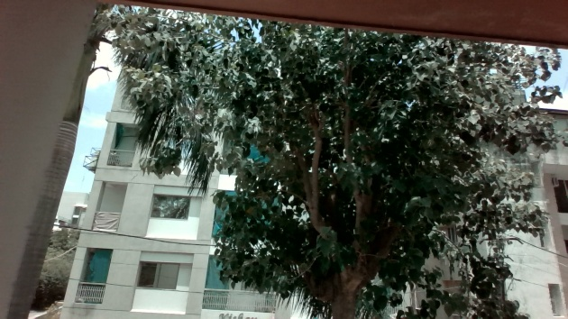

USB Webcam Verification
I used the built-in webcam of my laptop for this practical. I opened the Camera app in Windows and checked the live video to verify that the webcam was working properly. Then, I captured a photo using the Camera app. This confirmed that the webcam was functioning correctly.
2.Set up a local printer (USB or network), install the correct driver, and print a test page to confirm successful installation.

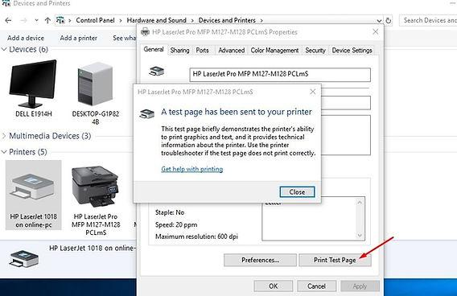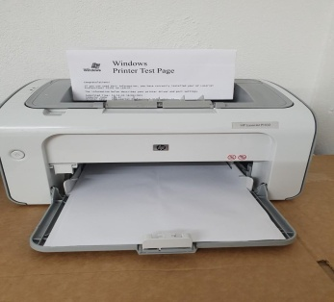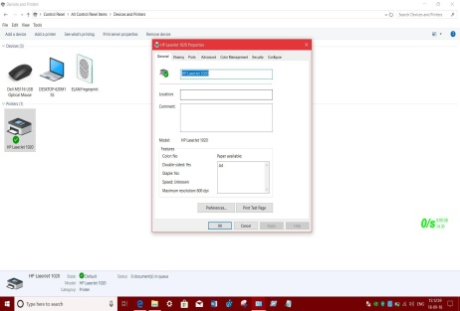

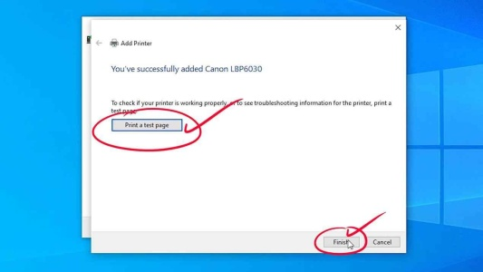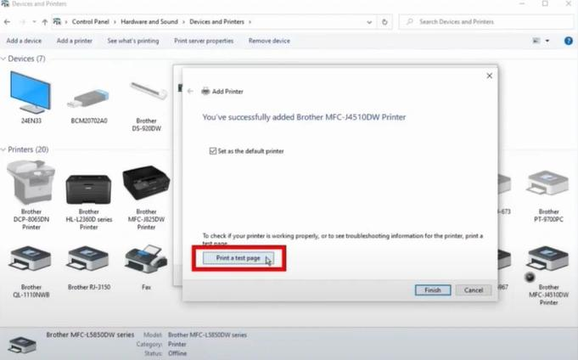

Setting Up a Local Printer and Printing a Test Page
- First, I connected the printer to my computer using a USB cable. If it was a network printer, I connected it to the same Wi-Fi network as my computer.
- I turned on the printer and waited for Windows to detect it.
- Windows installed the required printer driver automatically. If the driver was not installed, I downloaded and installed the correct driver provided by the printer manufacturer.
- After the installation was complete, I opened Settings → Devices → Printers & scanners and checked that the printer appeared in the list.
- Then, I selected the printer, clicked Manage, and chose Print a test page.
- The test page printed successfully, confirming that the printer was installed correctly and working properly on my computer.
3.Simulate a connectivity issue by unplugging the printer's USB cable, then use Windows Device Manager to identify and resolve the 'printer not detected' problem.<br><br><em><strong>Hint:</strong> Check for error icons and use the 'Scan for hardware changes' option after reconnecting.</em>

->Resolving a "Printer Not Detected" Problem Using Device Manager
- First, I unplugged the printer's USB cable from the computer to simulate a connectivity issue.
- Then, I opened Device manager by right-clicking on the Start button and selecting Device manager .
- I checked the list of devices to see if the printer had a yellow warning icon or appeared under unknown device .
- After that, I reconnected the printer's USB cable properly to the computer.
- In Device Manager, I clicked on action and selected scan for hardware changes so that Windows could detect the printer again.
- Once the printer appeared in the list without any error icon, I confirmed that the issue had been resolved.
- Finally, I checked the printer settings and printed a test page to verify that the printer was working correctly.
4.A user reports that their webcam video is not displaying in Zoom, but it works in the default camera app. Troubleshoot and resolve the issue so the webcam works in both applications.<br><br><em><strong>Hint:</strong> Check if another app is using the webcam or if Zoom permissions are enabled.</em>
->Troubleshooting Webcam Not Working in Zoom
- First, I checked whether the webcam was working in the Windows Camera app. Since it was working there, I understood that the webcam itself was not faulty.
- Then, I closed the Camera app and any other applications that might be using the webcam because only one app can sometimes access the camera at a time.
- After that, I opened Zoom and went to Settings → Video to make sure the correct webcam was selected.
- I checked Windows Settings → Privacy → Camera and confirmed that camera access was turned on for the device and that Zoom had permission to use the camera.
- I restarted Zoom and tried joining the meeting again to see if the video was displayed.
- If the problem still continued, I restarted the computer and checked for Zoom updates.
- After following these steps, the webcam started working properly in both the Camera app and Zoom.

